**LOW LEVEL DESIGN**

**Amazon Sales Data Analysis**

|  |  |
| --- | --- |
| **Written By** | **Priyanshu Gupta** |
| **Document Version** | **1.0** |
| **Last Revised Date** |  |

Contents

1.Introduction ................................................................................................................ 4

1.1 What is Low-Level design document ...................................................................... 4

1.2 Scope ........................................................................................................................ 4

2. Architecture ................................................................................................................ 5

1 Data Sources ................................................................................................................ 5

2 Power BI Desktop ........................................................................................................ 6

3 Power BI Service .......................................................................................................... 6

4 Power BI Report Server ................................................................................................ 6

5. Power BI Gateway........................................................................................................ 6

6 Power BI Mobile............................................................................................................ 6

7. Power BI Embedded ..................................................................................................... 6

3. ARCHITECTURE DESCRIPTION ............................................................................. 7

3.1Data Description........................................................................................................... 7

3.2Data Loading ............................................................................................................... 7

3.3Data Transformation .................................................................................................... 8

3.4Data Modelling ............................................................................................................. 8

3.5 DEPLOYMENT:.......................................................................................................... 9

4. UNIT TEST CASES ..................................................................................................... 10

1. **Introduction**

1.1 **What is Low-Level design document?**

The purpose of this low-level document is to provide a comprehensive guide for

analyzing Amazon e-commerce sales data. The document will cover the steps

required to gather, clean, and analyze the data, as well as interpret the results

and take actionable steps to improve sales performance. This document is

intended for data analysts, business intelligence professionals, and anyone who is

interested in analyzing Amazon e-commerce sales data to gain insights into the

performance of the platform.

1.2 **Scope**

Low-level design (LLD) is a component-level design process that follows a step-by

step refinement process. The process can be used for designing data structures,

required software architecture, source code and ultimately, performance

algorithms. Overall, the data organization may be defined during requirement

analysis and then refined during data design work.

2. Architecture

Power BI is a business suite that includes several technologies that work

together. To deliver outstanding business intelligence solutions, Microsoft

Power BI technology consists of a group of components such as:

* Power Query (for data mash-up and transformation)
* Power BI Desktop (a companion development tool)
* Power BI Mobile (for Android, iOS, Windows phones)
* Power Pivot (for in-memory tabular data modeling)
* Power View (for viewing data visualizations)
* Power Map (for visualizing 3D geo-spatial data)
* Power Q&A (for natural language Q&A)

1. Data Sources

An important component of Power BI is its vast range of data sources. You can

import data from files in your system, cloud-based online data sources or connect

directly to live connections. If you import from data on-premise or online services

there is a limit of 1 GB. Some commonly used data sources in Power BI are:

* Excel
* Text/CSV
* XML
* JSON
* Oracle Database
* IBM DB2 Database
* MySQL Database
* PostgreSQL Database
* Sybase Database
* Teradata Database
* SAP HANA Database
* SAP Business Warehouse server
* Amazon Redshift

2.Power BI Desktop

*Power BI Desktop is a client-side tool known as a companion development*

*and authoring tool. This desktop-based software is loaded with tools and*

*functionalities to* connect to data sources, transform data, data modeling

and creating reports.

3. Power BI Service

Power BI Service is a web-based platform from where you can *share reports made*

*on Power BI Desktop, collaborate with other users, and create dashboards.*

It is available in three versions:

* Free version
* Pro version
* Premium version

Power BI Service is also known as, **“Power BI.com”**, **“Power BI Workspace”,**

**“Power BI Site”** and **“Power BI Web Portal”**. This component also offers

advanced features like *natural language Q&A* and *alerts*.

4. Power BI Report Server

The Power BI Report Server is similar to the Power BI Service. The only difference

between these two is that Power BI Report Server is an on-premise platform. It is

used by organizations who do not want to publish their reports on the cloud and

are concerned about the security of their data.

Power BI Report Server enables you to create dashboards and share your reports with

other users following proper security protocols. To use this service, you need to have

a Power BI Premium license.

5. Power BI Gateway

This component is used to connect and access on-premise data in secured

networks. Power BI Gateways are generally used in organizations where data is

kept in security and watch. Gateways help to extract out such data through secure

channels to Power BI platforms for analysis and reporting.

6. Power BI Mobile

Power BI Mobile is a native Power BI application that runs on iOS, Android,

and Windows mobile devices. For viewing reports and dashboards, these

applications are used.

7. Power BI Embedded

Power BI Embedded offers APIs which are used to embed visuals into custom

applications.

3. ARCHITECTURE DESCRIPTION

3.1 Data Description

The dataset contains E-Commerse Sales data of Amazon for the year 2010 to

2017

**Amazon Sales Data Contains**

1. Region - Continent or Region of the Sales Country

2. Country - Name of the Country of Sales happened

3. Item Type - It is The Category of the product

4. Sales Channel - Mode of the Sales (Online or Offline)

5. Order Priority - It is Priority of the product (**H C L M**)

6. Order Date - Date of order registered

7. Order ID - Unique id number of order to track the order

8. Ship Date - Date of the ordered product got shiped

9. Unit Sold - Amount of quantity sold for that order

10.Unit Price - Amount sold to costumer per Unit

11.Unit Cost - Orginal price of the Unit

12.Total Revenue - Total revenue of the order

13.Total Cost - Orginal total cost of sold units

14.Total Profit - Profit gained in that order(Total revenue – Total Cost)

1.Customer Key- Unique Number given to customer

2 Date Key - Date When Customer Purchase Item

3 Discount Amount – Discount Given To Customer

4 invoice Date - Billing Date

5 Invoice Number - Bill Number

6 Item Class - It is The Category of the product

7 Item Number – Number Assign To Customer

8 Item – Product Number

9 Line Number -

10 List Price – Prices Of Customer

11 Order Number – Order Number

12 Promised Delivery Date

13 Sales Amount – Total Amount of Sales

14 Sales Amount Based on List Price

15 Sales Cost Amount- How much Spend on Selling Product

16 Sales Margin Amount – Actual Profit

17 Sales Price – Product Sold On This Price

18 Sales Quantity – How Much Quantity Sold

19 Sales Rep

3.2 Data Gathering

Step 1:- Open Power BI Desktop Application

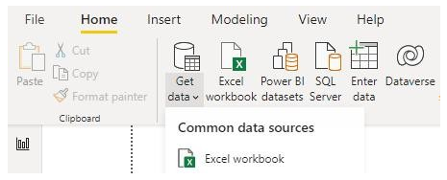Step 2:- Click on Get Data ◊ Click on excel

Step 3:- Browse to the data file on your system and select

Step 4:- Once Data is loaded click on **Transform data** in the bottom for further

transformation.

3.4 Data Transformation

In the Transformation Process, we will convert our original datasets with other

necessary attributes format and change the features according to the problem statement

on Power BI ETL tool Power Query as the data is in excel format.

A new Dim_ date table created for easy time intelligence analysis the features are:

1.Day of Week

2.Month name

3.Year

4.Year quarter

5.Month

6.Date

3.5 Data Modelling

After the data is transformed the data is modeled for visualizing and analysis

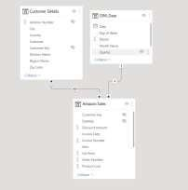

3.4 DEPLOYMENT:

After completing Dashboard Follow the Steps to

deploy the report Step 1:- Click on **Publish** on the

ribbon.

Step 2:- A box will pop just click on **my workplace** and **select**

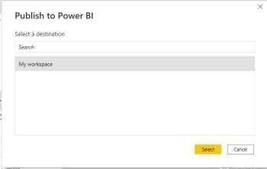

Step 3:- Now your report is published just click on open to check your report.

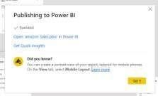

Step 4:- Report is published now explore your report

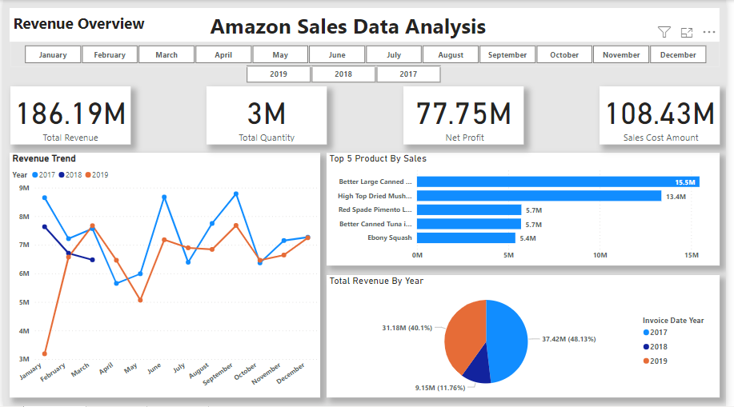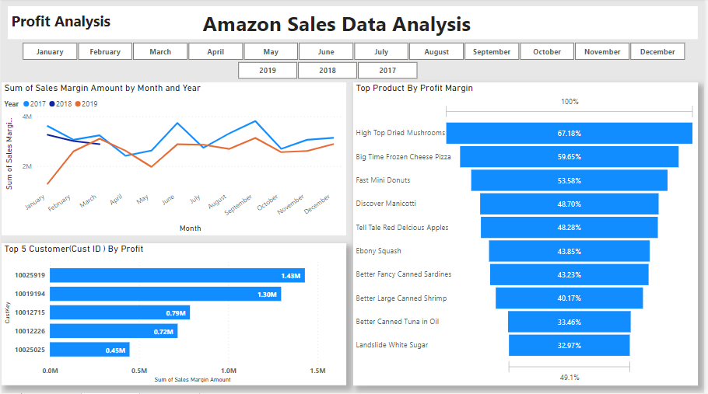

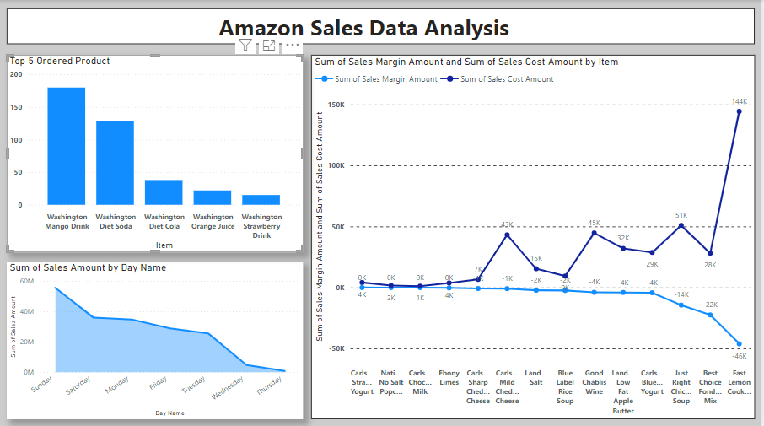

4. UNIT TEST CASES

